Rotary Club of Kathmandu Mid-Town
Breakfast Chatter




6 April 2012 The Weekly Bulletin of Rotary Club of Kathmandu Mid-Town Bc-4.06/011-12

District: 3292 Web: www.rotarymidtown.org.np Club Id : 26776

APRIL IS MAGAZINE MONTH
April is Magazine Month, a time to celebrate the global network of Rotary’s official magazines, which provide valuable information to 1.2 million Rotarians.

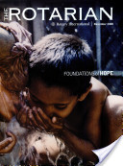

30 March, Friday
Charter President Dr Roop Jyoti was the in-house speaker for the day.
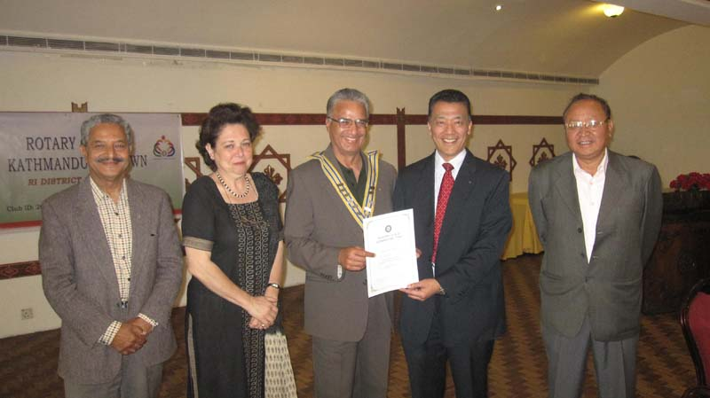
Certificate of appreciation being given to CP Dr Roop.
IPP Pratap, VP Isabella, President Som, CP Roop and PP Arun in the picture

Weekly Meetings and Programs :
Date | Program/Speaker | Program/Topics of Presentation
6 April 2012 | Kedar B Adhikary | City environment protection
13 April 2012 | Jitendra Joshi | US Education

India is no longer polio endemic:
Global support from Rotarians
"With the support of their Rotary brothers and sisters around the world, Indian Rotarians have worked diligently month after month, year after year, to help organize and carry out the National Immunization Days that reach millions of children with the oral polio vaccine," says RI President Kalyan Banerjee, of the Rotary Club of Vapi, Gujarat. "As an Indian, I am immensely proud of what Rotary has accomplished. However, we know this is not the end of our work. Rotary and our partners must continue to immunize children in India and in other countries until the goal of a polio-free world is finally achieved."
"India is tantalizingly close to eradicating polio," says Past RI President Rajendra K. Saboo, who chaired the Polio Summit. "Rotary International has committed to be the torchbearer until India and the world become polio-free."
Robert S. Scott, chair of Rotary's International PolioPlus Committee, calls India's achievement "a significant step towards a polio-free world – an example as to what can be accomplished no matter what problems need to be overcome. Rotarians of India are and should be proud of the key efforts they have made at all levels, without which the world would not be marking this milestone."
Deepak Kapur, chair of the India PolioPlus Committee, also credits the Indian Ministry of Health and Family Welfare for its commitment to ending polio. To date, the Indian government has spent more than US$1.2 billion on domestic polio eradication activities. "We are fortunate that our government is our biggest advocate in this effort," Kapur says.
Source: Dan Nixon/Rotary International News


Creating positive change means, at its simplest, using our knowledge and resources to solve a
problem. But when we are talking about solving humanitarian problems in a real and lasting
way, knowledge and ideas and resources are not enough to ensure results. We have to
remember something else that is no less important: sustainability.
RI President Kalyan Banerjee

On Lighter Side : Click here ⇩


A thought for the day:
If a rabbit defined intelligence the way man does,
then the most intelligent animal would be a rabbit,
followed by the animal most willing to obey the commands of a rabbit.
- Robert Brault

Thousand-ship flotilla to mark UK queen’s jubilee:
A seven-mile flotilla of 1,000 ships will sail down the river Thames in one of the biggest and most spectacular events ever seen in London to mark Queen Elizabeth’s 60 years on the throne. The $15 million pageant will include a royal barge and feature some 20,000 participants, historic boats, working vessels, small kayaks, musicians and an orchestra, as well as a unique floating bell tower. Organisers predict millions will watch along the 25-mile stretch of the river where the flotilla will pass, with hundreds of millions expected to tune in on TV across the world to see the most dramatic display of British pomp and ceremony witnessed on the river since the 17th century.
The pageant will take place on Sunday 3 June during four days of celebrations to herald the queen’s jubilee, travelling under 14 bridges along the Thames and taking some 90 minutes to pass any point along the way.
Pageant Master Adrian Evans said it would be ‘the greatest collection of historic vessels ever to be gathered in London’.
Source: The Himalayan Times

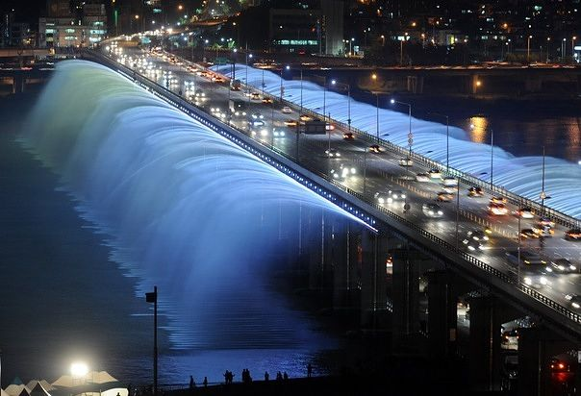
Balloons in Cappadocia Banpo bridge Seoul

Please send project/activity information, suggestions and photos etc to :
BC Editor: RR Shrestha email: rryes@wlink.com.np

6 April 2012 The Weekly Bulletin of Rotary Club of Kathmandu Mid-Town bc-4.06/011-12

